**Additional features of Oxygen XML editor**

**Index**

**1. Tracking changes in DITA topics 3**

**2. Adding comments 5**

**3. Viewing tags added 6**

# **Tracking changes in DITA topics**

* When you add any content in existing topics , to track that changes we can use this feature
* Select options 🡪 preference 🡪 enable tracking of deletion and insertion

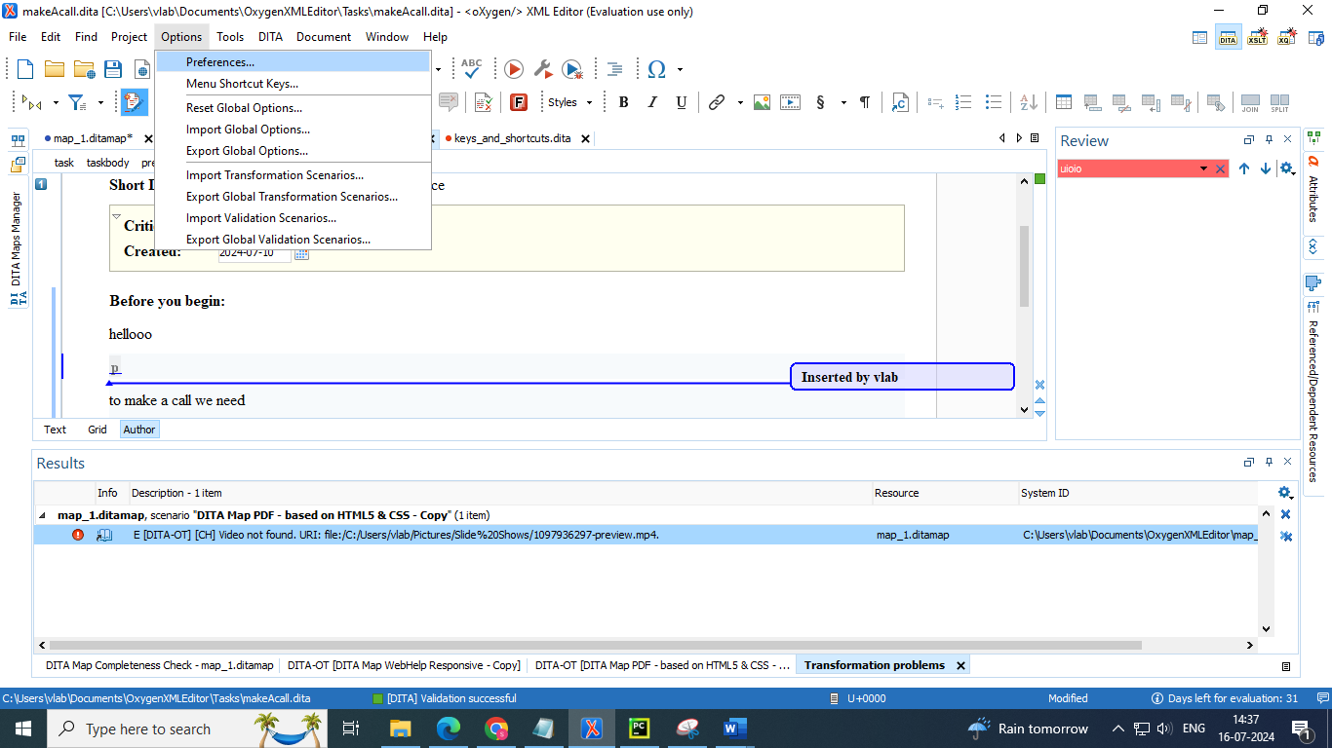

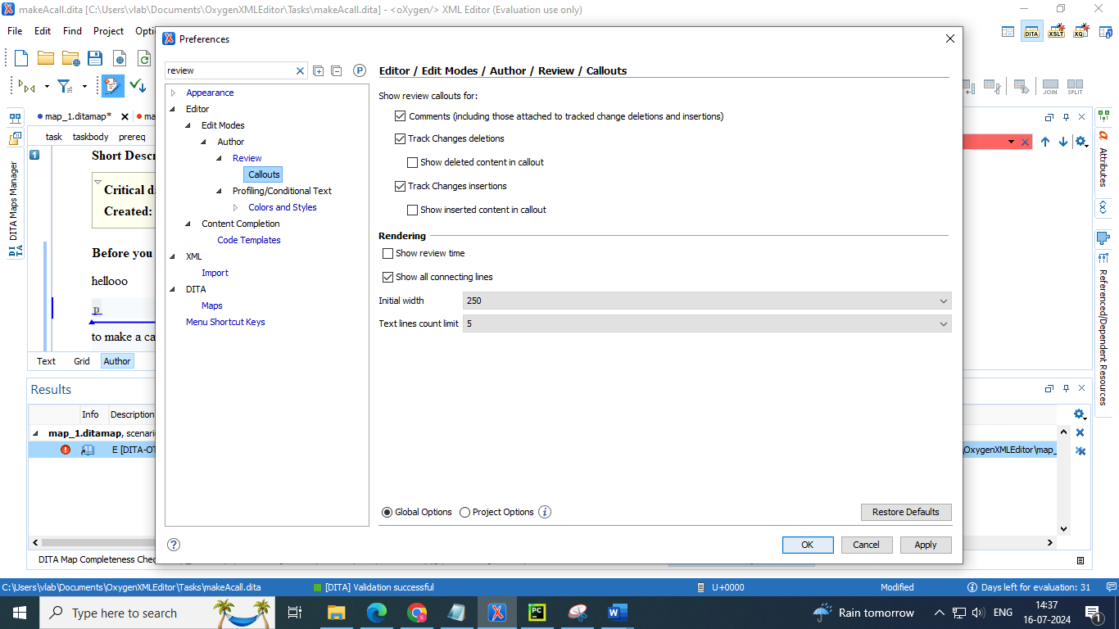

* Select window 🡪 show view 🡪 more 🡪 review : to view the changes we have made in the topics

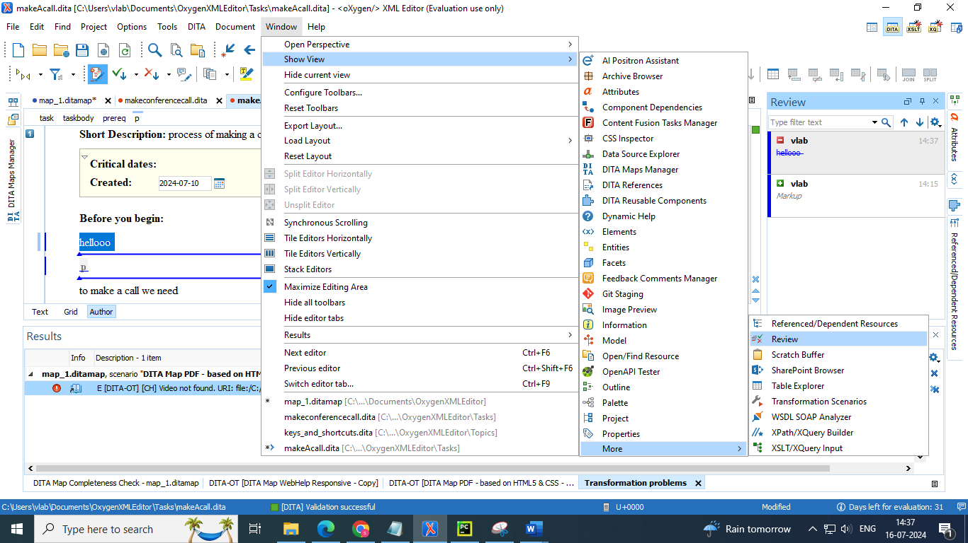

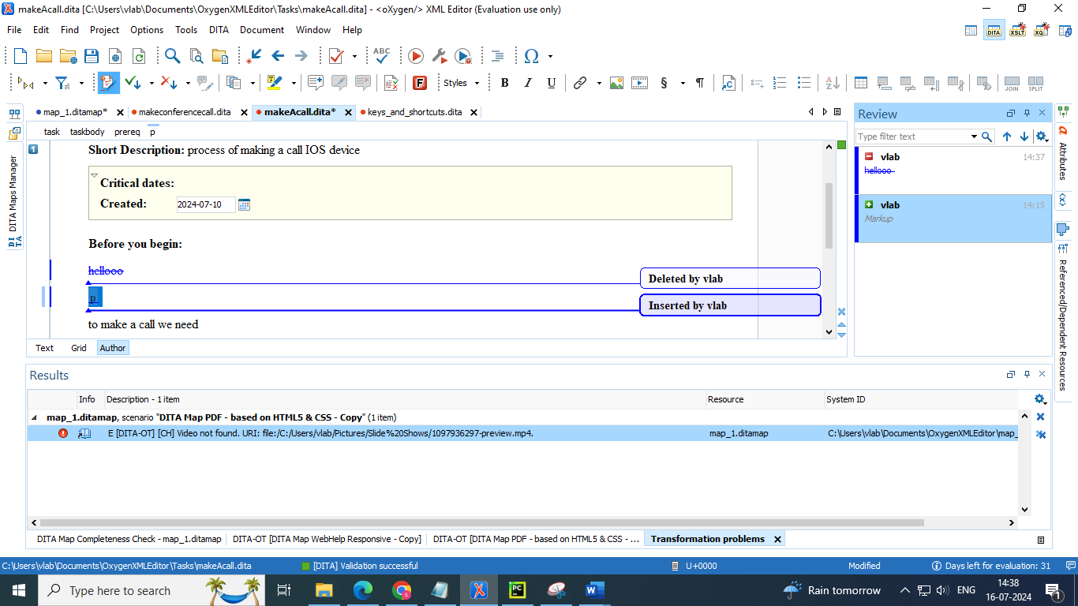

# **Adding comments**

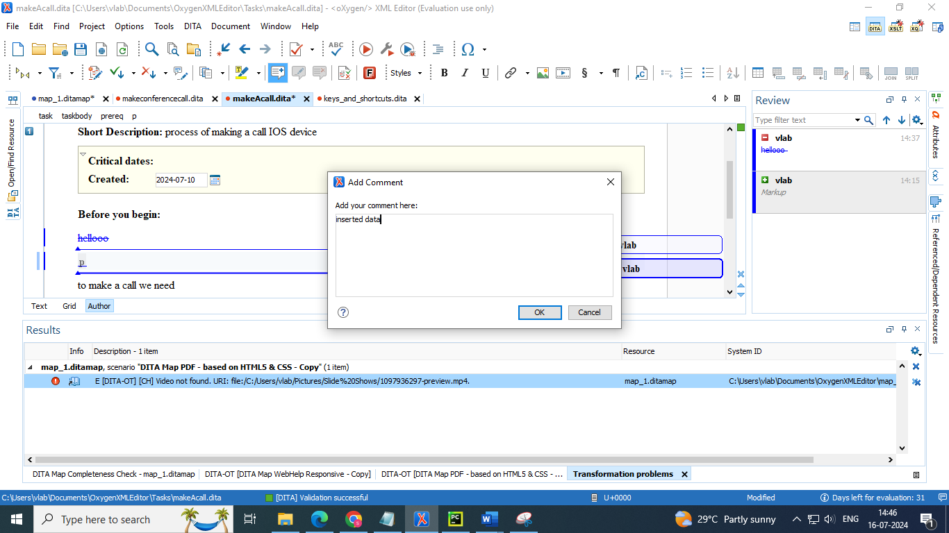

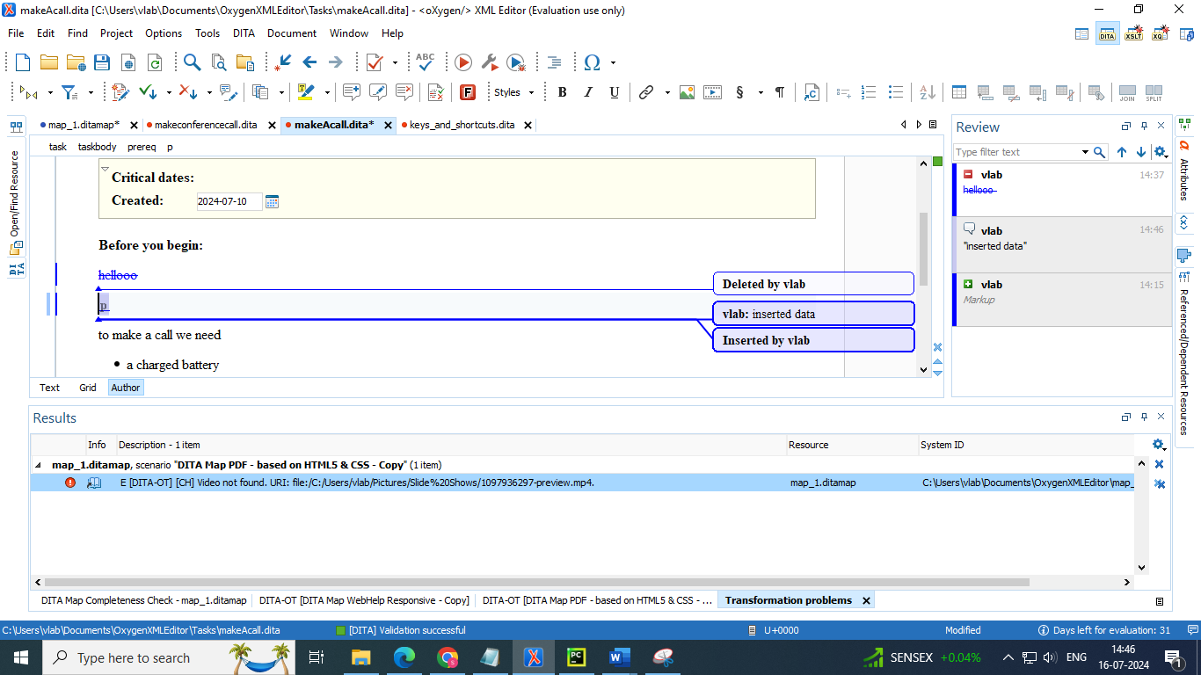

# **Viewing tags added**

